MUSHROOM PRODUCTIONS
Introduction
Mushroom provides supplementary food and is a common delicacy during the rainy season in Malawi. Not all mushrooms are edible. Examples of wild edible mushrooms: Nyozwe, Chifwiwi, utale. Utale is the most liked one and it is white and medium size. Apart from being wild and forest product, mushrooms can be grown and become a viable faming business.
Mushrooms are the fruiting bodies of a certain class of fungi called basidiomycetes. These are the most common type of fungi during rainy season.
Some characteristics of fungi
- They have no chlorophyll and hence cannot produce their own food like other plants
- They depend on other organism for food, absorbing nutrients from the organic material in which they live, i.e. obtain nutrients by absorption
- Reproduce through spores or by budding. The living body of the fungi are the mycelium which is made of thread-like filaments called hyphae.
Fungus ecology
- Depending on the mode of living, fungi are classified into three
- Saprophytes: they live on dead material or organic debris
- Symbionts: they live together with other organisms in a close relationship (symbiosis).
- Parasites: they live at the expense of organisms (parasitic).
Life cycle of fungi
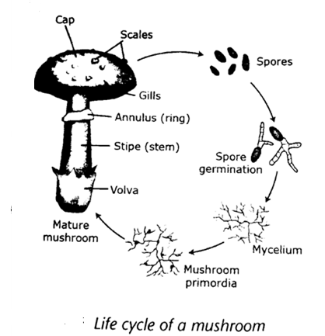
- The cap produces spores which upon failing on a favourable environments, will germinate to from mycelium.
- The mycelium forms secondary mycelium through the fusion of two sexually but compatible mycelium
- Secondary mycelium form the fruiting body (mushroom)

PARTS OF A MUSHROOM
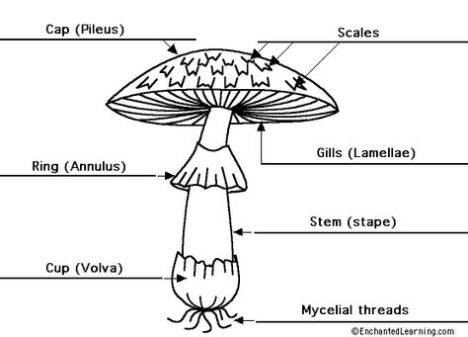

Parts of a mushroom
- Mycelium
- Underground part of the mushroom. It has the hyphae (very tiny filaments often white in colour). It can live for hundreds of years if food is available
- Function: they absorb organic matter and water from the soil for the growth of mushroom
- Fruiting body (sporosphere)
- Part above the ground. It can only live for few days. It has the following parts
- Stalk(stalk/stipe): it supports the cap and transport water to the cap
- Cap: it protects the gills of the mushroom
- Gills: located under the cap. It produces fertile spores
- Spores: they are tiny seeds. Form the reproductive part of the mushroom
- Volva: it is the remains of membrane that covered the immature mushroom. It ruptures as the stem grows.
- Ring: it is the membrane that covers the ruptured gills as the cap grows.it is located under the cap and circles the stem.
- Scales: these are rough patches of tissues on the surface of the cap. These are remains of the veil.
- Veil: this is a thin piece tissue that connects the cap to the stem in young mushroom

Cultivated species of mushroom in Malawi
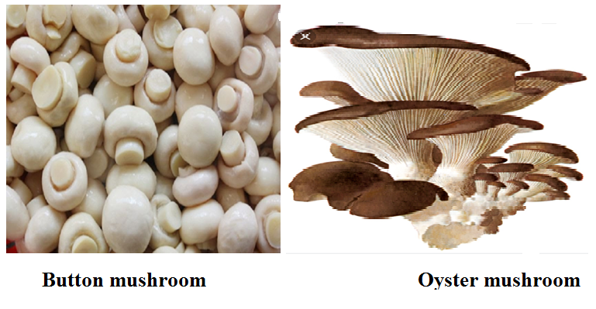
- Oysters species
- Light tan to cream in colour
- It has a large fan-like cap and short stem
- It is delicious flavour and can be eaten raw in salad or cooked. It is also used as an ingredient in soup
- Button species
- It is hard and dome shaped
- The colour varies from white to light brown
- It has nice flavour and can be used in salads and soup
- It can be canned or driers.
- Shiitake species
- It is broad and has an umbrella shaped cap
- Its colour ranges from tan to dark brown
- It tastes like steak when cooked
- Button mushroom
- Two varieties are recommended.
- TNS 1
- Requires a cropping temperature of$16℃-20℃$.
- It is white in colour
- Has potential yield of 15kg per square metre.
- TNS 2
- Requires a cropping temperature of$18℃-22℃$. It is bigger than TNS 1
- It is white in colour and scaly with a potential yield of 15kg square metre.
- The temperatures are prevalent between March and July in most parts of the country. Therefore mushroom can best be grow in these months
Differences between oyster mushroom and button
- Oyster mushroom are easier to grow than button
- Button have better taste than oysters
- Oyster are less capital intensive than button
- Oyster have shorter shelf life than button
- Oyster fetch lower prices on the market than button
- Oyster are good for beginning mushroom growers because
- easier to grow
- less capital intensive
- Button mushroom require special compost and fertiliser and hence farmers find it difficult and expensive to produce.

Importance of mushroom production
- They are source of food, providing proteins, vitamins and minerals which are vital for good health.
- They are also good source of income to growers
- They are source of foreign exchange
- Mushroom production can assist in diversification and provides a better way of utilising crop, forestry and animal wastes.
- After cultivation, the substrate can be used as manure
Husbandry practices for mushroom production
- Selection of species
- Selection of site
- Construction of incubation and production sheds
- Substrate preparation
- Spawn source (buying and preparation)
- Substrate treatment
- Mushroom seeding
- Mushroom fruiting management
- Harvesting
- Selection of species
Factors to consider when selecting species for mushroom
- Availability of waste material used as growth medium
- Presence of suitable environmental conditions
- Availability of expertise in growing mushroom
- Availability of capital
- Market demand for species you want to grow. Always checks the taste and preference of consumers in your area. You should aim at satisfying the need of consumers
- Site selection
- It should be away from livestock kraal, rubbish pits and latrines to avoid attracting flies
- It should be near a market in order to sell mushrooms fast since they are highly perishable
- It should be near a dense forest to provide an ideal condition for mushroom growth because humidity and availability of woods
- It must be free from pests and diseases otherwise mushroom can be destroyed
- Climate conditions. A warm rainy and humid environment. temperature range of 12-24
- Availability of transport for both produce and substrate so that they rich are of need faster.
- Construction of incubation and production house
- Cultivated mushroom are grown in a house
Qualities of a good mushroom house
- The house should include a dark for incubation and light production room for fruiting
- The house should provide a suitable humidity, temperature, ventilation and moisture
- Ensure ventilation by use ventilators and doors which face in face in the direction of wind and shelves to prevent carbon dioxide build up in the house
- Use of insulation materials (plastic sheet and grass thatch) to prevent temperature fluctuation in the house and increase efficiency of air conditioning.
- Should be solid and sloping for easy cleaning and to allow water to drain
- Sand should be placed on the floor since it absorbs water
Positioning of the house
- Should face the windward side and should be shielded from the sun
- It should be well ventilated
Materials for constructing incubation
- Poles, heavy gauge, plastic sheet, grass, bamboos, timber, nails, wires or plastic gauze.
Procedure for constructing incubation and production sheds for mushroom
- Clear the site
- Measure site 5m by 3m
- Digging of the holes and fixing the poles into them
- Construct the walls of the house 2m high using bamboos, strings or twigs
- Construct shelves inside the sheds 0.5m to 1.0m in width. The length depends on the size of the sheds
- Thatch the walls with grass
- Cover the remaining 0.5m of the walls from the roof with a clear plastic sheet
- substrate preparation
- substrate is any material which is organic in nature on which mushroom grows
Materials for substrate preparation
- maize Stover, rice hush, maize cobs, cotton wastes, saw dust, banana leaves
Ingredients (supplements) which can be added to the substrate
- molasses, fertiliser, like single super-phosphate, lime, chicken manure, soya beans powder or cotton seed cake
PROCEDURE FOR PREPARING MUSHROOM SUBSTRATE
- steps for preparing maize Stover (maize stalk, husks and cobs) as substrate for mushroom
- chop the materials into smaller length (shredding process) for easy filling into sucks
- soak them for few hours so as to soften them up
- drain the water (blending process)
- treat the substrate to kill the germs
- steps for preparing cotton wastes as a substrate for mushroom
- soak the cotton wastes for few minutes in water mixed with detergents as a softener and disinfectant
- squeeze water out of the cotton wastes
- loosen the cotton
- treat the substrate
- steps for preparing saw dust from hard wood as a substrate for mushroom
- moisten the saw e dusts
- add supplements’
- incubate it overnight
- add supplements
- treat the substrate
- steps for preparing rice bran as a substrate for mushroom
- soak the rice bran in powered soap solution like OMO for ten minutes
- rinse the substrate to clean water until all the soap bubbles have disappeared
- treat the substrate

- Spawn source
- Buying or preparation of spawn
- Spawn can be bought from the following places in Malawi
- Lilongwe sit of agriculture and natural resources
- Natural resources college
- Biology department at chancellor college
- Vumbwe research station
- Spawn preparation involves three stages
- Culture medium preparation
- Materials used as culture medium preparation
- Potato Dextrose Agar Substrate
- Malt extract agar
- Tissue culture collection and preparation
- Spawn colonisation
Stage 1: culture medium preparation
- Culture medium is nutrients agar substrate on which mushroom fungi will be grown
Martials used for culture medium preparation
- There two types
- Malt extract agar
- Potato dextrose agar or PDA
Process of preparation of nutrient agar substrate
- Wash and weigh 200g of European potatoes or ordinary potatoes and cut them into small pieces.
- Boil for 15 to 20 minutes in 1L of water until they are soft. Drain and save the water.
- Make water back up to 1 L with fresh water;
- add 20gm dextrose and 18-20 gm agar.
- Heat until the agar dissolves
- Sterilise the agar in autoclave for$121℃$,for 15 minutes.
- Culture medium is poured into test tubes ($1/4$ full) or Petri dishes ($1/2$ full)
- Let the medium cool on the laminar airflow table
Process for preparation of Malt extract agar
- Add 20g of the extract to 1L of water and 18-20g of agar
- Heat until the agar is dissolved
- Put into bottles
- Plug and sterilise
Note that: malt extract agar can be available in both syrup or powder and they are normally found with amateur beer makers.
Note: laminar airflow table is an enclosed bench designed to prevent contamination of biological samples. The device separates air flowing through it into layers.
Stage 2: tissue culture collection and preparation
Materials needed
Fresh mushroom, alcohol (spirit or ethanol), razor, blade and forceps, cotton wool, bottles

Procedure
- Wash hands in alcohol to make them free from germs
- Break the mushroom with clean hands to expose the gills
- Remove the tissues between the gills and the upper part of the mushroom using forceps
- Place the tissue in sterilised test tube or petri dishes using the forceps
- Close the bottles near a flame with cotton wool
- Place the petri dishes and the bottles in an incubator or at room temperature
Stage 3: spawning (spawn colonisation)
Materials needed: sorghum, millet, and whole rice
Procedure
- Soak all the materials for preparing spawn in water for a day
- Remove the water
- Put the materials in sterilised bottles
- Sterilise the materials
- Let the contents cool
- Mix(inoculate) the tissue culture with the sterilised materials
- Put the inoculated bottles into an incubator for 15 days. The mycelium would have colonised the materials by that time
- Substrate treatment: the substrate should undergo sterilisation process to kill germs
Sterilisation
- Sterilisation by steam

- Home-made sterilizer
- This is made from an open drum with a perforated platform (with holes)
Procedure
- Put some stones in the drum to create a platform
- Pout 10 litres of water into the drum
- Fill the drum with substrate
- Cover the top with a plastic sheet and make a hole in the middle of the plastic as a safety valve
- Tighten the drum with a sisal string or linya
- Heat the drum until steam reach the top
- Leave the substrate to cool
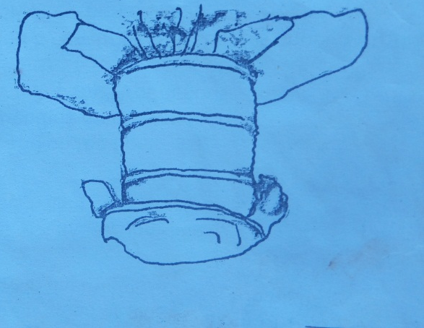

- Use of autoclave
- Pack the substrate in the wire mesh baskets
- Put the basket into the autoclave machine and sterilise the substrate for 1 hour
- Remove the baskets from the machine and empty the content on the plastic sheet and let it cool
- Note that: substrate should be properly treated to avoid infection since mushrooms are sensitive to poor hygiene
- Sterilisation by immersion in hot water
- Soak the chopped materials in hot water for 3 hours to soften them up
- Drain the water
- Chemical sterilisation by soaking in water
- Mushroom seeding: seed for mushroom is called spawn
Procedure for seeding mushroom
- Wash hands thoroughly
- Pack the substrate into plastic bags
- Broadcast three quarters of the required amount of spawn in the substrate
- Mix the spawn with the substrate through
- Broadcast the remaining spawn on the top layer of the substrate
- Tie the mouth of the bag with a string
- Incubate the spawn bags in the dark rooms or covet with a plastic sheet until bags are fully colonised (if colonisation is successful the whole substrate will turn white) colonisation take place after 21 days depending on the temperature.
- Transfer them into the fruiting house where there is enough light for mushroom to start forming
- Tie the bags on the racks and make few slits on the bags using a razor blade or a sharp knife.
- Mushroom fruiting management
- Mushroom fruiting is the stage where mushrooms emerge from mycelium. The activities involved are
- Monitoring the spawn running
- Monitor the spawn as it develops until running on the running on the substrate
- A white colour indicates the growth of mycelium. If no growth occurs, it implies that the substrate is too wet/too dry or the temperature was too low.
- Casing should be done when mushroom have begun to emerge thus 14 days after the substrate is fully colonised with mycelium.
- Casing is the process of adding moist soil to the spawn.
- Clay loam taken from sub soil and should be low in organic matter content and PH between 7.0 and 7.5.
- temperature of moist soil should be between $16℃ and 22℃$
- It is put on top of compost for about 3 to 4cm and bout 30kg of soil is required per square metre.
Importance of casing
- promotes and stimulates formation of fruiting bodies
- Retains the needed moisture for mushroom growth

- Monitoring the colour change
- The normal colour of mycelium is white. It is important to monitor colour change to know whether there is growth or not. If the substrate is green or pink in colour or partly showing signs of white growth it means the temperature of the fruiting house is too high
- Hanging in the production sheds
- When the bugs are fully colonised hung them in the production sheds
- Importance: it ensures that all bags receive enough light
- Watering
- It is done by sprinkling water on the bags, wall and on the floor
- It is done twice or three times a day depending n the weather.
- Importance: to maintain freshness and humidity in the mushroom house (above 80%) this will enhance fruit development
- Note that: freshness in the house can also be maintained by ensuring that there is enough ventilation in the house by routine opening of vents to avoid accumulation of carbon dioxide
- Accumulation of carbon dioxide will lead to development moulds and bacterial
Harvesting mushrooms
FACTORS TO CONSIDER WHEN HARVESTING MUSHROOM
- Maturity of the mushroom
- Ready for harvesting when button appear which fetch high price on the market.
- Mushroom can also be harvested when the caps appear (when the veils have opened).
- Can also be harvested when the flats appear and at this time the veils open up and the caps are flats and gills are fully opened.
- Market requirement
- Most consumers prefer button to the rest because mushroom have a good taste at this stage.so most farmers harvest mushrooms before they start to open. Flats have less demand on the market.
- Plucking
- Mushrooms are ready for harvesting after 14 to 20 days after casing and they come in weekly flushes. Harvest mushroom at the right time to ensure continuous formation of the new ones. Leaving mushrooms for a longer period without harvesting will only increase the size of mushroom not the number. The right stage for harvesting depends on one’s own market.
- Marketing
- Mushrooms ready for markets are divided into three grades depending on the size and degree of maturity. These are
- Buttons: these are small enclosed mushroom. They fetch high prices on the market because of good taste
- Caps: these are older buttons. These are mushrooms whose veils have opened but still have rounded caps. They have medium size value
- Flats: these are the mushrooms whose veils have fully opened, the caps are flats and the gills are fully exposed. They fetch low prices at the market.
PROCEDURE FOR HARVESTING MUSHROOM
- Hold the cap
- Twist the mushroom
- Pull it together with the roots
- Cut off the root
- The hole left behind should be filled with fresh casing soil
- Watering of beds should be done soon after harvest
Essay question 2019
Describe any five factors to consider when harvesting mushroom
- Market- when harvesting mushroom there must be a market already available
- Prices-mushroom should be harvested when demand is high
- Maturity of mushroom-it is important for the farmer to harvest the mushroom when it has fully matured
- Threat to pests, diseases and theft; when a farmer knows that the mushroom is at risk for being stolen or damage they have the mushroom
- Transport –farmers should consider securing transport when harvesting mushrooms to ensure that they reach customers quickly
- Labour-whenever mushroom is to be harvested it is important to have enough personnel so that the mushrooms should be harvested quickly
PEST AND DISEASES OF MUSHROOMS
- Main pests of mushrooms include: flies, rats, snails and mites
- Phorid and scarid flies
- Are attracted by the odour of the mycelium
- The flies do not harm the mushrooms as such but they lay their eggs on the mycelium
- It is the larvae (maggots) which eat and damage the stems, gills and mushroom themselves.
Control
Flies can be controlled by
- Keeping the fruiting rooms clean
- Removing the old and contaminated bags regularly
- Setting up fly light traps
- Nematodes are known to prey on the mushroom fly larvae
- Rats
- Are usually a problem if the surroundings are dirty
- They damage the substrate bags
Control
- Setting traps
- Keeping the surrounding clean
- Keeping cats
- Snails
- Eat mushrooms at night
Control
- By hand picking and killing them
- Bats and traps are also used
- Use of salts
- mites
- are tiny spiders
- they eat mycelium or the actual mushrooms
- they are also carriers of green moulds caused by Trichoderma and other fungal diseases
Control
- by spraying quicklime
- spraying malathion
- beetles
Damage caused
- eat the fruits
- make holes in the gills and hide inside
Control
- hand picking and destroying them
Diseases of mushrooms
Examples of other fungal diseases
disease | Diseases causing organism | Damage caused | control
Dry bubble | Verticilium fungicola | - Distortion and spotting  - Mushroom stems with tilted cap  - Mushrooms are deformed | - Proper hygiene and sanitation  - Sterilisation of substrate
Wet bubble | Mycogone pernicious | Mushroom are deformed | - Use of bacterial and actinomycetes as biological measures  - Steaming at 54.4$℃$. for 15 minutes  - Spray benomly
Cob web | Cladobotyum dendroides | Soft rot or decay of fruiting body | - Sterilisation  - Sanitation and hygiene (regular cleaning and removing dead mushrooms)  - Spraying fungicides such as chlorinated lime
Trichoderma green moulds (most common disease ) happen when the substrate is contaminated  It is an air borne disease and can also be transmitted by flies and mites | fungus | Green moulds appear as spots on the dead mushroom and substrate | - Remove contaminated substrate  - Splaying chemicals  - Observe hygiene

